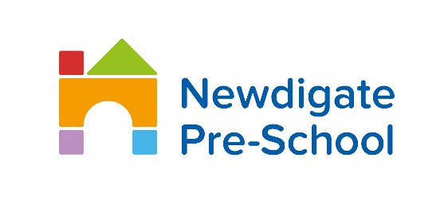
Newdigate Pre-school Terms and Conditions
Pre-School Places and Bookings
A signed and fully completed application form must be received before a place or any changes are confirmed. Session times are not flexible. There is a minimum booking of two sessions per week. Fees are billed on a half-termly basis (with government funding reductions applied where appropriate) and must be paid by the end of each half term to maintain your child’s place. Any one-off extra sessions are billed separately and payable on receipt of invoice. Payments may be made by cheque, internet-banking, via the ‘Famly’ app or employer childcare vouchers. Failure to meet payments may result in the termination of your Pre-School place. In such cases, the parent remains responsible for all outstanding fees.
Late Collection of Children
It is important for the children and staff that children are collected promptly. Whilst we appreciate that delays are sometimes unavoidable, we reserve the right to charge £5 per 15mins to cover the cost of staff overtime. Please attempt to call us to let us know you will be late and the approximate time of arrival.
Pre-School Opening Dates
The Pre-School is open for 38 weeks of the year. On occasion, there may be circumstances beyond our control (for instance weather conditions, flooding, medical emergencies, pandemics) that means the decision has to be taken to close the Pre-School. If the Pre-School is obliged on these occasions to pay the staff, then the Pre-School reserves the right to charge for any session which your child would have attended if the Pre-School had not been closed due to circumstances beyond its control.
Termination/Cancellation Change
We require half a terms written notice (6 weeks) should you wish to terminate a pre-school place or reduce your sessions for any reason. Parents remain liable for fees throughout the notice period. We reserve the right to terminate a Pre-School place with immediate effect if a parent or child displays abusive, threatening or otherwise inappropriate behaviour. If a start date is postponed or cancelled we reserve the right to charge from the original start date. If you wish to change the number of sessions, a ‘A Registration and Change’ form must be completed.
Liability and Insurance
We have extensive insurance cover and full details are on display outside the main entrance. We cannot be held responsible for any loss or damage to children’s property. Every reasonable effort will be made to ensure children’s belongings are not lost or damaged. We accept no responsibility for children whilst in their parents care on Pre-School/School premises.
Accidents and Illness
We reserve the right to administer basic first aid and treatment where necessary. Parents will be informed of all accidents and required to acknowledge this via the ‘Famly’ app. For accidents of a more serious nature, involving hospital treatment, every effort will be made by the Pre-School to contact parents but failing this we are hereby authorised to act on behalf of parents and authorise necessary treatment. We will only administer prescribed medicines if parents complete a ‘medicine consent form’; however, the first dose must be given at home and medicines must not be left on the Pre-School premises overnight. We require parents to withdraw their child from Pre-School in the event they require special medical care or attention, the child is considered too unwell to attend or it is thought the child has an infectious or contagious disease/infection (eg chicken pox). We accept no responsibility for children contracting contagious diseases/infections but efforts will be made to inform parents of cases of such diseases or infections within the Pre-School. We reserve the right to contact parents at any time if their child becomes ill during normal pre-school hours. Should your child pose a potential health risk to other children or staff then we have no option but to exclude the child until a doctor declares no further risk. Parents are required to inform Pre-School if their child is suffering from any illness, sickness or allergies.
Security
Under no circumstance will a child be allowed to leave Pre-School with anyone unknown unless the Parent has made previous arrangements. A list of responsible adults who are authorised to collect your child, along with a password, should be given to the Pre-School Manager.
General Information
Parents are required to inform Pre-School of any food, medicine, activity or other circumstance that may cause the child to have an allergic reaction or allergy. Parents must provide full details, in writing, of the severity of the reaction and must keep the Pre-School informed of any change to the condition. In the event that you seek to employ a member of our staff, you will be liable to pay costs to cover advertising and replacement to the sum of three months’ salary or £2,000 whichever is the greater. This is effective within and up to three months of an employee leaving our Pre-School.
Agreement
We reserve the right to update/amend these Terms and Conditions at any time with one months notice.

